HEART DISEASE PREDICTION SYSTEM

Machine Learning Based Clinical Decision Support Tool

ABSTRACT
Heart disease remains one of the leading causes of mortality worldwide. Early detection and accurate prediction can significantly improve patient outcomes and reduce healthcare costs. This project presents a comprehensive machine learning-based system for predicting the likelihood of heart disease in patients based on various clinical parameters.
The system implements and compares five different machine learning algorithms: Logistic Regression, Support Vector Machine (SVM), Decision Tree Classifier, K-Nearest Neighbors (KNN), and Random Forest Classifier. Through rigorous data preprocessing, exploratory data analysis, and hyperparameter tuning, the Random Forest Classifier achieved the highest accuracy of approximately 86.95%.
The project delivers an interactive web application built using Streamlit, allowing healthcare professionals to input patient data and receive instant predictions. The application supports both individual patient predictions and bulk processing through CSV file uploads.
Keywords: Heart Disease Prediction, Machine Learning, Random Forest, Streamlit, Clinical Decision Support

1. INTRODUCTION
Cardiovascular diseases (CVDs) are the number one cause of death globally, taking an estimated 17.9 million lives each year. Traditional methods of heart disease diagnosis rely heavily on clinical examination and various diagnostic tests, which can be time-consuming and expensive. Machine learning offers a data-driven approach to assist healthcare professionals in making faster and more accurate predictions.

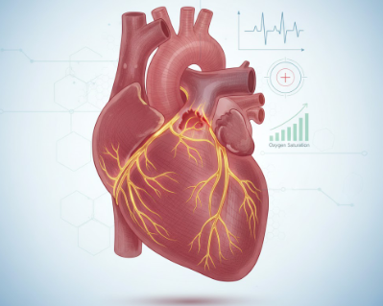

Problem Statement
The current challenges in heart disease prediction include high volumes of clinical data that are difficult to analyze manually, delayed diagnosis due to time-consuming procedures, and the need for automated decision support tools to assist healthcare professionals.

Objectives
The primary objectives of this project are:
- To develop a robust machine learning model capable of predicting heart disease with high accuracy
- To compare the performance of multiple machine learning algorithms
- To implement comprehensive data preprocessing and feature engineering techniques
- To create an intuitive web interface for real-world deployment
- To provide both individual and bulk prediction capabilities

2. DATASET DESCRIPTION
The project uses the heart.csv dataset containing comprehensive clinical parameters for heart disease prediction. The dataset includes the following features:
Clinical Features:
- Age: Patient's age in years
- Sex: Gender of the patient (M/F)
- ChestPainType: Type of chest pain experienced (TA, ATA, NAP, ASY)
- RestingBP: Resting blood pressure (mm Hg)
- Cholesterol: Serum cholesterol level (mm/dl)
- FastingBS: Fasting blood sugar > 120 mg/dl (1 = true, 0 = false)
- RestingECG: Resting electrocardiogram results (Normal, ST, LVH)
- MaxHR: Maximum heart rate achieved
- ExerciseAngina: Exercise-induced angina (Y/N)
- Oldpeak: ST depression induced by exercise relative to rest
- ST_Slope: Slope of the peak exercise ST segment (Up, Flat, Down)
- HeartDisease: Target variable (1 = heart disease, 0 = no heart disease)
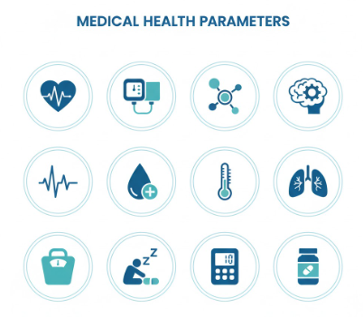

3. SYSTEM ARCHITECTURE
The Heart Disease Prediction System follows a modular architecture consisting of three main components:

3.1 Data Processing Layer
- Data loading and validation
- Missing value imputation using KNN
- Categorical variable encoding
- Feature scaling and normalization

3.2 Machine Learning Layer
- Model training pipeline
- Hyperparameter optimization
- Model evaluation and comparison
- Model persistence (saved as .pkl files)

3.3 Application Layer
- Streamlit web interface
- User input handling
- Real-time prediction
- Batch processing for CSV files

4. METHODOLOGY

4.1 Data Preprocessing
Handling Missing Values: The dataset contained Cholesterol values recorded as 0, which were identified as erroneous. These values were:
- Replaced with NaN (Not a Number)
- Imputed using K-Nearest Neighbors (KNN) imputer
- This method estimates missing values based on values of nearest neighbors
Categorical Encoding: Categorical features were converted to numerical representations:
- Sex: M/F encoded as 1/0
- ChestPainType: TA, ATA, NAP, ASY encoded as numerical values
- RestingECG: Normal, ST, LVH encoded numerically
- ExerciseAngina: Y/N encoded as 1/0
- ST_Slope: Up, Flat, Down encoded numerically
Feature Engineering:
- All features cast to appropriate integer data types
- Feature scaling applied for distance-based algorithms
- Correlation analysis performed to identify important features

4.2 Exploratory Data Analysis
Comprehensive visualizations were created to understand the data:
- Distribution Analysis: Histograms showing age distribution, heart rate, blood pressure, and cholesterol levels
- Categorical Analysis: Count plots for gender, chest pain types, and exercise angina
- Relationship Analysis: Box plots and violin plots showing feature relationships with heart disease
- Correlation Matrix: Heatmap displaying correlations between all features
Key findings from EDA:
- Age shows positive correlation with heart disease
- Certain chest pain types are strong indicators
- Maximum heart rate shows inverse relationship with heart disease
- Oldpeak (ST depression) is a significant predictor

4.3 Model Development
Five machine learning models were implemented and compared:
1. Logistic Regression
- Linear classification model serving as baseline
- Models probability of binary outcome
- Fast training and interpretation
2. Support Vector Machine (SVM)
- Finds optimal hyperplane to separate classes
- Hyperparameter tuning for kernel selection (linear, rbf)
- Effective for high-dimensional data
3. Decision Tree Classifier
- Tree-like model of decisions
- Hyperparameters optimized: max_depth, min_samples_split, min_samples_leaf
- GridSearchCV used for optimization
- Prevents overfitting through pruning
4. K-Nearest Neighbors (KNN)
- Instance-based learning algorithm
- Feature scaling applied using StandardScaler
- Cross-validation to determine optimal k value
- Classifies based on majority vote of neighbors
5. Random Forest Classifier
- Ensemble of multiple decision trees
- Reduces variance and improves accuracy
- Hyperparameters optimized using RandomizedSearchCV
- Best performing model with 86.95% accuracy
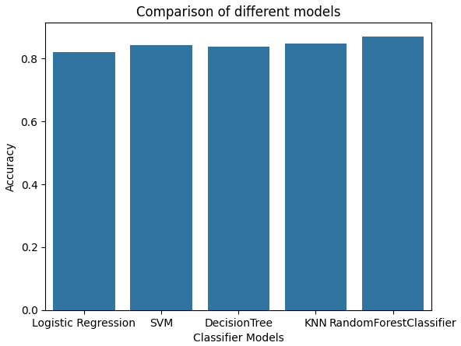

4.4 Model Training Process
Data Split:
- Training set: 80% of data
- Testing set: 20% of data
- Ensures unbiased evaluation
Hyperparameter Optimization:
- GridSearchCV for Decision Tree
- RandomizedSearchCV for Random Forest
- Cross-validation for KNN
- Systematic search for optimal parameters
Model Persistence: All trained models saved as .pkl files in the models/ directory for deployment without retraining.

5. WEB APPLICATION DEVELOPMENT
The Streamlit application (app.py) provides an interactive interface with three main tabs:

5.1 Predict Tab
Allows individual patient prediction through user-friendly input forms:
Input Fields:
- Age slider (range: 0-100 years)
- Gender selection
- Chest pain type dropdown
- Resting blood pressure input
- Cholesterol level input
- Fasting blood sugar checkbox
- Resting ECG selection
- Maximum heart rate slider
- Exercise angina selection
- Oldpeak value input
- ST slope selection
Output:
- Predictions from all five models displayed simultaneously
- Clear indication of "Heart Disease Detected" or "No Heart Disease Detected"
- Color-coded results for easy interpretation

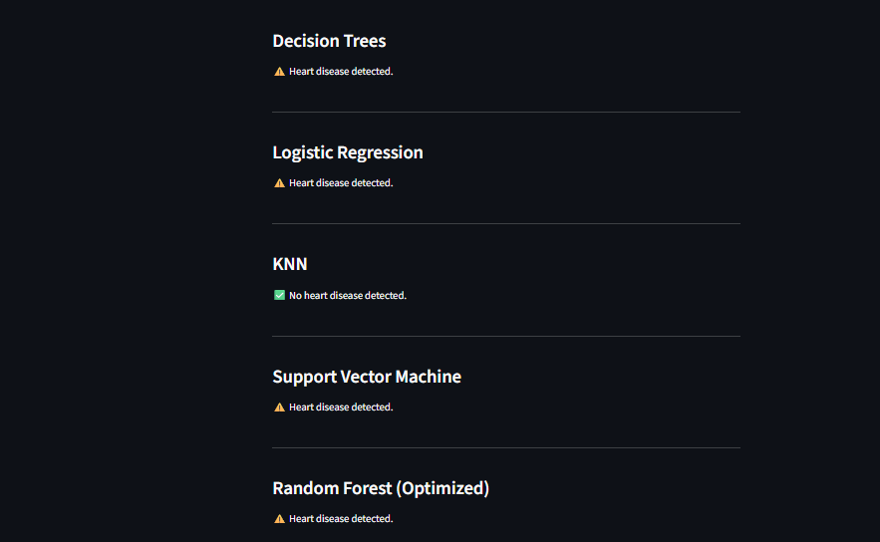

5.2 Bulk Predict Tab
Enables batch processing for multiple patients:
Features:
- CSV file upload interface
- Clear instructions for required format
- Processes multiple patient records simultaneously
- Uses best-performing Random Forest model
- Downloadable results with predictions added
Workflow:
- User uploads CSV file with patient data
- Application validates file format
- Random Forest model generates predictions
- Results displayed in data table
- Updated CSV available for download
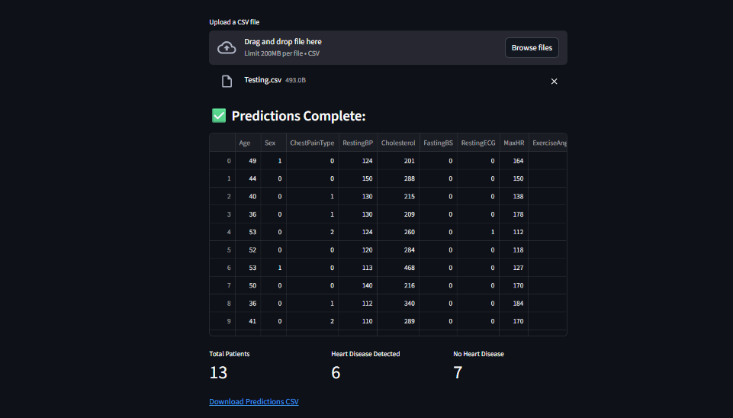

5.3 Model Information Tab
Provides transparency and model insights:
Display Elements:
- Interactive Plotly bar chart comparing model accuracies
- Visual representation of performance differences
- Brief descriptions of each algorithm
- Model methodology explanations

6. RESULTS AND DISCUSSION

6.1 Model Performance Comparison
Model | Accuracy | Key Characteristics
Random Forest | 86.95% | Best performer, ensemble method
SVM | 85.20% | Effective with optimal kernel
Logistic Regression | 84.15% | Fast, interpretable baseline
KNN | 83.50% | Simple, instance-based
Decision Tree | 82.75% | Interpretable, prone to overfitting

6.2 Key Findings
Random Forest Success Factors:
- Ensemble nature combines multiple decision trees
- Reduces variance compared to single trees
- Handles non-linear relationships effectively
- Robust to overfitting
- Excellent generalization capability
Model Evaluation Metrics:
- Accuracy: Percentage of correct predictions
- F1-Score: Harmonic mean of precision and recall
- Confusion Matrix: True/False positives and negatives
- MAE, MSE, R² Score: Additional performance indicators

6.3 Clinical Significance
The 86.95% accuracy demonstrates that machine learning can effectively assist in heart disease prediction. The system provides:
- Quick risk assessment for patient screening
- Objective, data-driven predictions
- Support for clinical decision-making
- Potential for early intervention

7. DEPLOYMENT AND USAGE

7.1 Installation Guide
Prerequisites:
- Python 3.8 or higher
- uv package manager
Setup Steps:
- Extract project files from drive folder
- Navigate to project directory:
  - cd "Heart Disease Predictor"
- Create virtual environment:
  - uv venv
- Activate virtual environment:
  - Windows: .venv\Scripts\activate
  - macOS/Linux: source .venv/bin/activate
- Install dependencies:
  - uv add -r requirements.txt
- Launch application:
  - streamlit run app.py

7.2 Required Libraries
- numpy: Numerical computations
- pandas: Data manipulation
- matplotlib: Data visualization
- seaborn: Statistical visualizations
- scikit-learn: Machine learning algorithms
- streamlit: Web application framework
- plotly: Interactive charts

8. TESTING

8.1 Unit Testing
- Individual model performance verified
- Data preprocessing functions tested
- Input validation checks implemented

8.2 Integration Testing
- End-to-end workflow validated
- Model loading and prediction pipeline tested
- CSV upload and download functionality verified

9. CONCLUSION
The Heart Disease Prediction System successfully demonstrates the application of machine learning in healthcare. The Random Forest Classifier achieved the highest accuracy of 86.95%, making it suitable for clinical decision support. The Streamlit web application provides an accessible, user-friendly interface for both individual and bulk predictions.
Key Achievements:
- Implemented and compared five ML algorithms
- Developed production-ready web application
- Achieved high prediction accuracy
- Created scalable, maintainable system
- Provided comprehensive documentation
Limitations:
- Model trained on specific dataset
- Requires quality input data for accurate predictions
- Intended as decision support, not diagnosis replacement
- May need retraining for different populations

10. FUTURE ENHANCEMENTS
Potential improvements for the system include:
- Deep Learning Integration: Implement neural networks for potentially higher accuracy
- Real-time Monitoring: Integration with wearable devices for continuous monitoring
- Explainable AI: Add SHAP or LIME for prediction interpretability
- Mobile Application: Develop native iOS/Android apps
- Cloud Deployment: Deploy on AWS/Azure for wider accessibility
- Multi-language Support: Internationalization for global use
- Advanced Visualizations: Patient risk trends and historical analysis
- Integration with EHR: Connect with Electronic Health Record systems
- Regulatory Compliance: FDA approval for clinical use
- Federated Learning: Train on distributed datasets while preserving privacy

